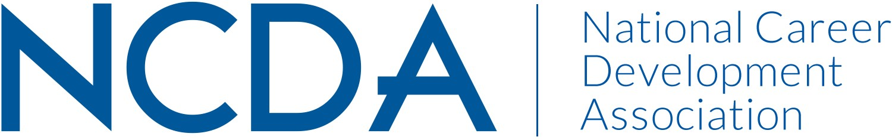

GOVERNMENT RELATIONS COMMITTEE

March, 2018

Co-Chairs: Michael Marlowe michaelJmarlowe@gmail.com Mobile, 919-327-7235
Diana M. Bailey, dibailey@comcast.net H: 410-730-3857, **Mobile: 443-996-1788

Action Committee Members: Ashley Moore, Niel Carey, Rebecca Dedmond, Michael Cichowicz, Lisa Severy, and Cynthia McDuffie

For Committee:
Currently there are 42+ committee members who receive email updates, requests, and information. Michael Cichowicz is serving as the liaison to the state GR members. We periodically send Legislative Action Alerts from LobbyIt and other GR partners i.e. ACTE, ASCA and others with shared interests in Career Development services.

Committee Activities to Date:
- Board initially cut the funding for LobbyIt services as of Oct. 2017. Upon concerned response of the GR Action Committee, and with the submission of additional documentation, they were reinstated until Sept. of 2018 for their services and completion of their work plan with the GR Action Committee.
- Developed GR Committee and State GR Mission Statements (See attached) and shared with Wendy. Only one state response to date (Idaho)
- Developed NCDA Member Tips for Engaging Members of Congress (attached)
- Update and communicate LobbyIt contact, Jason Ortega, who advocates with key members of congress
- Monthly GR committee meeting on the third Tuesday of the Month.
- Submitted a letter of support to the Committee on Veterans Affairs. Ashley Moore GR Action Committee Member will represent NCDA on the workgroup. Here are a few bullet points about the TAP Reform roundtable. She also submitted a document to Jon Clark (Staff Director of this subcommittee) outlining how NCDA can be involved. (Submitted to NCDA previously but request another copy as needed)
- Mike Marlowe met with Commerce Under Secretary Walter Copan and discussed the importance of career counseling for advanced manufacturing.
- Mike Marlowe previously met with Pam Frugoli at DOL. Pam would like to meet with representatives of NCDA to discuss collaborative opportunities between DOL and NCDA. Date pending April, 2018
- 1/30/18- Roundtable on TAP Reform hosted by the Subcommittee on Economic Opportunity of the House Committee on Veteran Affairs.

Rep. Jodey Arrington (R-TX), Chairman Rep. Brad Wenstrup (R-OH)
Rep. Beto O’Rourke (D-TX), Ranking Member Rep. Mark Takano (D-CA)
- There is strong desire within congress to improve the TAP program and make it a proactive guide to career development (per Rep. Arrington)
- -more education needed on credentials and college selection (Rep. Takano)
- -Still in early phases of determining end goals to inform any changes/redesign of the curriculum
- -They need methods to gauge the effectiveness and outcomes of TAP (DOL is conducting a study)
- -This is early in the process! NCDA could provide insights in the areas of Assessment, Curriculum Planning, Credentialing of Instructors, and other research from a counseling perspective.
****They want a strong focus on career and educational counseling...who better to than an organization of career counseling professionals?
- Letter submitted by LobbyIT on behalf of NCDA re the Task Force on Apprenticeships under US Sec. of DOL. No response to date. The NCDA whitepaper was also included as part of the justification for Career Development services for all youth and adults.
- Engaging the Administration on apprenticeship, amidst their push to increase the number of apprenticeships and transfer much of the burden to the private sector
- Working with the veterans committee to engage congress on transition assistance
  - Engaging House subcommittee tasked with reform
  - Engaging Senate offices that have introduced bill on this issue
  - Working to secure invitations for NCDA representatives to address staff members at Hill briefing
- Identifying newly introduced legislation and working with GR Committee to determine best engagement strategy
  - S2443 – Careers Act
  - S2379 – Military Spouse Employment Act of 2018
- LobbyIT is supporting the Committee with their efforts to expand state level GR engagement

Projected Plan/Work Completed through September 30, 2018
- List board activities or committee/council activities that are not yet started and the plans to complete them.
  - Possible survey of CDA presidents/leadership re their state and local GR efforts.
  - Convening for Spring 2018 in DC with Key legislators. LobbyIT and committee are working on April dates with Mike Marlowe will also be in the area.
  - Planning for GR conference session in June. Information submitted to MaryAnn Powell
  - Given continued shifts in DC re legislative priorities, we are working with LobbyIT to potentially reassess our strategy as new career related legislation appears and will need our advocacy. LobbyIT, is determining whether DOL is the best agency to get what we want or if we need to shift. Additionally, by April, we may have a few Hill meetings that could also yield results due to some recently introduced legislation.
  - Michael Cichowicz to be listed on the website as Liaison to the GR committee by state reps.

ATTACHMENTS AVAILABLE AGAIN UPON REQUEST

