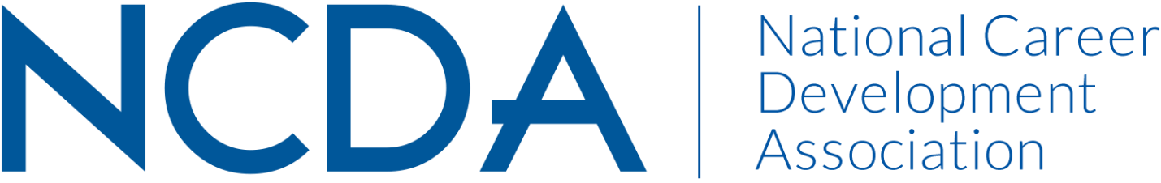

Annual Report 2020-21

CAREER CONVERGENCE, WEB MAGAZINE
August 17, 2021
Melanie Reinersman, Editor, webeditor@ncda.org
Associate Editors: Marty Apodaca, Abiola Dipeolu, David Dietrich, Melissa Fickling, Francine Fabricant, Sarah McElroy, Billie Streufert, Michelle Tullier, Melissa Venable
Field Editors: Vera Chapman, Mason Murphy, Janine Rowe, Willa Smith

Activities to Date
- Welcomed two new Co-Associate Editors for Counselor Educators and Researchers dept and one for Independent and one for Features. One new Field Editor started and one ended.
- Published new issues on the first of each month (except Jan 1 and July 1), bringing the total issues up to 192 (since 2003); Acknowledged the 18th Anniversary of Career Convergence
- Published 7 new articles, plus one Tech Tip, each month. Electronic distribution to over to 22,000 emails on the first of the month
- Social justice topics are regularly covered and diversity of articles and authors is evident throughout each issue via title, topic, and author bio.
- Presented the web magazine at the 2021 NCDA Virtual Global Conference via a recorded presentation on the new NCDA website
- Recorded 30 day hit rate for each issue’s articles
- Held a zoom call for editors on Nov 18, 2020 and July 21, 2021
- Brainstormed hot topics and posted under Submissions, for potential authors
- Tweeted each month, with links to the issue and each article
- Selected (by editors’ votes) the annual “Career Convergence Recognition Award” winner who was recognized during the annual NCDA Global Conference.
- Posted a proto-type article to show potential authors a sample edited article
- Implemented image updates to the Career Convergence section of the website in relation to the new NCDA website, with attention to diversity of image subjects
Projected Plan/Work Completed through September 30.
- Continue to publish monthly web magazine; encourage diversity in topic and authors and connection to 2022 conference theme.
- Search for replacement Associate Editors for two depts.
- Prepare to present the web magazine at the Career Practitioner Institute in October.
- Initial work to begin on a content analysis of the web magazine.

