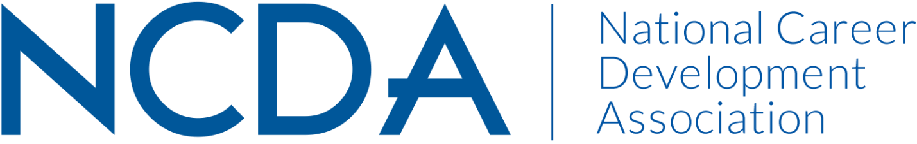

Annual Report 2020-2021

GRADUATE STUDENT COMMITTEE
Date of Report: August 24, 2021

Chair: Kellee Watkins (kelleewatkins@att.net or kwatkins3@niu.edu)
Co-Chair: Scott Farmer (Scott.S.Farmer@outlook.com)

Committee Members:
Shannon Thomison, Professional Development Chair
Rose Oku, Social Media Chair
Molly Schuller, Historian
Erin Kilpatrick, 2021 Virtual Mixer Coordinator
Susan Henderson

Activities to Date
- Installed new chair and co-chair in April 2021
- Hosted Graduate Student Virtual Networking Event at NCDA 2021 Conference on 6/30/2021
  - Event introduced committee to NCDA Graduate Student Members
  - Recruited two new committee members
- Created 3 subcommittees to achieve FY 2022 goals and establish foundation.
  - Social Media
  - Professional Development
  - Vision and Succession Planning

Projected Plan through fiscal year end (September 30th)
- Transition to Asana & GroupMe for project management and communication needs
- Continue developing committee bylaws and succession plan
- Develop Graduate Student Professional Development Resource Guide
- Partner with Ali Breen, NCDA Marketing Consultant to create a NCDA Graduate Student LinkedIn group to launch in November 2021.

If you received funding for your work, what specific outcome(s) benefited NCDA? N/A

