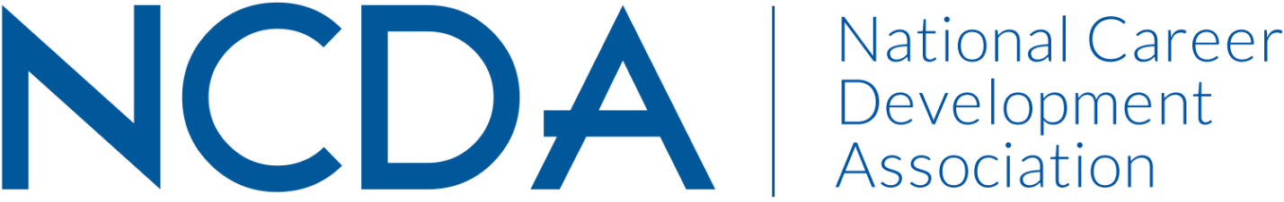

Annual/Mid-Year Report Template

Please prepare your report and submit electronically to dpenn@ncda.org by March 15, 2023, with a copy to your Board Liaison. These reports will be posted on the NCDA Website.

COMMITTEE/COUNCIL/COMMISSION NAME (in CAPS): DIVERSITY INITIATIVE AND INCLUSION COMMITTEE
Date of Report – 02/28/2023

Co-Chairs: Dr. Natasha Barnes – natashabarnes.ed.d@gmail.com; Mr. Ruben Britt – britt@rowan.edu

Committee Members (no contact information required)
Derek | Allenby
Nelinda | Avila
Elif | Balin
Carol | Balk
Sarah | Baquet
Natasha | Barnes
Kegan | Barroso
Manny | Bartalotta
Harold | Bell
Laura | Bethea
Jo | Boodon
Ruben | Britt, Jr.
Brianna | Burke
Monica | Cano
Kersey | Carla
Idaly | Cascante
Christian | Chan
Carla | Cheatham
Jonique | Childs
Kairise | Conwell
Kristen | Cooper
Greta | Davis
Melinda | DiBenedetto
Becca | Dickinson
Casey | Dozier
Rachel | Dupree
Priscilla | Edwards
Denise | Felder
Mia | Ferraina
Melissa | Fickling
David Julius | Ford, Jr.
Jill | Forest
Emily | Frank
Cyndi | Freeman
Breanna | Gallagher
Christine | Gist
Sharon | Givens
Dannette | Gomez Beane
Luke | Gorham
Celeste | Hall
Melanie | Hamon
Yas | Hardaway
Latoya | Haynes-Thoby
Towanna | Henderson
Ashley | Herman
Jehan | Hill
Kyla | Hines
Linda | Holloway
Ju | Hong
Chris | Horvath
Tekeia | Howard
Brian | Hutchison
Tristan | Hyatt
Kyle | Inselman
Kelli | Jackson
Gina | Johns
Kenya | Johnson
Deborah | Jones
Christie | Julien
Kendall | Klumpp
Amy | Kozlarek
Audra | Lavoie
Laura | Lee
Katherine | Lewis
Michelle | Lovasz
Cheryl | Love
Katie | Maguire
Mauli | Mahajan
Victor | Massaglia
Mark | McCloud
Michelle | Merrett
Alicia | Monroe
Rebecca | Montalbano
Ray | Moon
David | Murphy
Tashawn | Nichols
Midori | Nonogaki
Rose | Oku
Marlene | Orr
Lisa | Owens
Brian | Park
Josephine Jane | Pavese
Erin | Pearce
Sarah | Pearson
Cherrie | Peters
Julie | Peterson
Shawn | Pewitt
Brian | Pillsbury
Margaret | Randol
Delasia | Rice
Cashion | Rivers
Maronda | Robertson
Janine | Rowe
Lourdes | Servantes
Mary | Sweeney
Nina | Talley
Mitali | Temurnikar
Venita | Thomas
Lynn Z. | Tovar
Kalia | Vang
Sue | Vang
Paolo | Varquez
Holly | Waite
Courtney | Warnsman
Donna | Washington
Melissa | Wheeler
Andrea | Wieland
Deetra | Wiley
Benjamin | Wright
Galaxina | Wright

Activities to Date :
The DICI committee is working to support Goal 1 (Objective 2) of NCDA’s Strategic Plan. To address Obj. 2, the DICI subcommittees have developed a plan of action for the year.
-The Online Resources Sub-Committee is working to provide online resources that speak to the needs and interests of our members and non-members. This will consist of articles and other resources that could be helpful in relation to career issues in different populations. Also, this committee is working on a DEI calendar that will outline career with specific attention to months, weeks, and days set aside for different populations.
-The Informed Practices Sub-Committee will work to get 2 manuscripts published or under review – this will include work with the CDQ, Career Convergence, and any other publications that we can connect with to discuss viewing career through different cultural lens; this committee also plans to work with the Online Resources Committee to create set-up and maintain a blog dedicated to DEIB and Career Development and Planning.
-The Professional Development Sub-Committee is working to plan and execute the Social Justice Symposium at the 2023 NCDA Conference; additionally, this committee is planning to host 2 webinars by the end of the fiscal year.

Projected Plan through fiscal year end (September 30th)
The activities that we have underway are creating DICI-specific space on the website which is expected to be complete by March 2023. The calendar should be underway by March 2023 as well. One article has already been submitted for review to CDQ by a DICI sub-committee co-chair and an article will be submitted to Career Convergence by July 2023. The blog development and 2 blogs will be completed by September 2023. The symposium will take place in July 2023, and the 2 webinars will be completed by September 2023.

If you received funding for your work, what specific outcome(s) benefited NCDA? Unknown

