Cecil Broadnax, Jr., PhD
Candidate for Trustee – Higher Education Career Counselors and Specialists

Dr. Broadnax is a biomedical engineer turned educator, who invented medical devices credited with saving lives. His inventions are in every surgical operating suite. Dr. Broadnax was nominated for Engineer of the Year and has traveled the globe informing and training physicians on how to use his inventions and surgical procedures to ensure positive clinical outcomes.
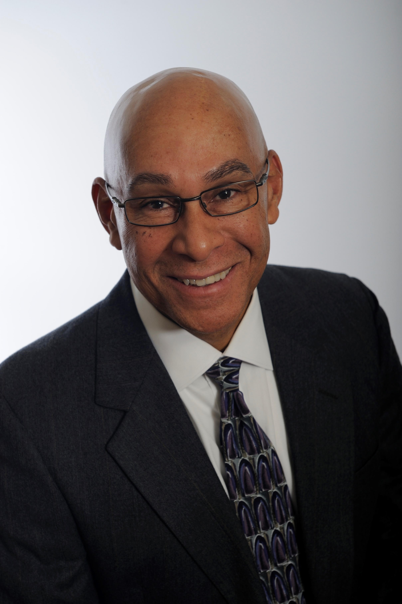

Dr. Broadnax is a passionate believer in education’s potential to shape and change lives. While attending graduate school, he was a volunteer teacher in West Philadelphia, which he credits for uncovering his unbridled passion for education as a way in which students can change their lives. That experience led him to several senior university appointments including Executive Director of Career Development Services; Dean of Student Services; and VP, Campus Director, and Faculty Member at Apollo Group. He sat on several university boards of trustees and advisory committees.

He has 30+ years’ experience building and leading higher education initiatives, programs, and organizations; and was recognized for his work by receiving several bi-partisan appointments from 5 US Governors and President Clinton, in recognition of his noteworthy accomplishments and outstanding service to communities, states, and the nation. Dr. Broadnax is currently Director of Workforce Development, Career Services, Alumni Services, and Employer Relations at Bryan University, fields in which he has much passion and experience. He shares Bryan University's commitment to and passion for helping students gain access to, matriculate, and complete higher education certificates and degree programs, to ultimately help change their lives.

Goal Statement

My primary goal is to build meaningful and effective synergistic relationships across NCDA and its partner universities. By working collaboratively and collegially with other equally passionate and experienced higher education professionals, together we will accomplish much and generate, develop, implement, assess, and refine effective programs to elevate students’ lives. The power of effective career development is unlimited and a pivotal point of support and encouragement in a college student’s life. I am well suited to provide the leadership through which NCDA can develop and support programs and processes that will encourage, support, and motivate students to pursue the profession of their dreams. We open the doors to their future, show them what’s possible, and help them develop the foundation to succeed, thrive and lead. NCDA is a lifelong support system for students and graduates. I am encouraged and excited to lend my support, enthusiasm, and passion. This is who I am.

