NCDA ANNUAL REPORT
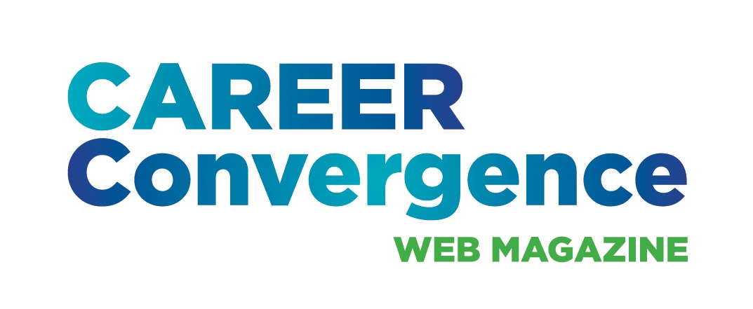

CAREER CONVERGENCE WEB MAGAZINE
September 7, 2023

Editor: Melanie Reinersman, webeditor@ncda.org

Associate Editors: Natasha Barnes, David Dietrich, Linda Evans, Melissa Fickling, Kyle Inselman, Amy Pierce-Danders, Vonya Hodrick, Elyse Pipitone, Billie Streufert, Jerilyn Wagner
Field Editors: Mason Murphy, Janine Rowe, Willa Smith

Activities to Date

- Received the APEX Award for Publication Excellence for the second time. Posted the award logo in the web magazine
- Published new issues on the first of each month (except Jan 1 and July 1), bringing the total issues up to 213 (since 2003)
- Published 7 new articles, plus one Tech Tip, each month. Electronic distribution to over 25,000 emails on the first of the month and approximately 1600 articles archived
- Brainstormed ideas and kicked-off celebration of the 20th anniversary of the web magazine, including a new logo, a social media campaign, an online article and article in Career Developments magazine
- Achieved record-high hit rates for three articles on the topics of social justice, values and cultural competency
- Continued with the 4th article in the series on women in the history of career development; planning for a series on teaching, from the Counselor Ed Academy participants
- Held a conference call on Dec 5, 2022 and met at the June conference; presented the web magazine in two sessions (one a joint presentation with Career Developments editor)
- Now using iStock for better quality/selection of images for articles
- Conference roundtable presentation on the CC content analysis
- Granted reprint request to Asia-Pacific CDA to use any articles, anytime. Fulfilled 5 requests for CEs
- Monitored comments posted on articles
- Tweeted each month, with links to the issue and each article
- Selected (by editors’ votes) the annual “Career Convergence Recognition Award” winner.

Projected Plan/Work Completed through September 30.

- Continue to publish monthly web magazine; begin search for new associate editors
- Hold a conference call to increase skills and knowledge of APA style for references and citations
- Continue the content analysis and determine ways to share/use the results

